

Formative Exam
Teacher : Candice Henriquez

======================================================

ANSWER SHEET
ECONOMICS
Your Name: _________________________

Question # | Answer | Question # | Answer
1 | C | 11 | 3000
2 | C | 12 | 5700
3 | B | 13 | 6900
4 | A | 14 | 4200
5 | A | 15 | Supply
6 | A | 16 | Shifts to the left
7 | A | 17 | Our GDP decrease and our prices increase (Cost push inflation)
8 | B | 18 | Cost Push Inflation
9 | B | 19
10 | D | 20

Multiple choice questions

- Lisa uses her income of NAf.25 to buy magazines and smoothies. The price of a magazine is NAf.10 and the price of a smoothie is NAf.5. If the price of a smoothie changes to NAf.6,
- Lisa’s budget constraint line shifts to the right without a change in the slope
- Lisa’s budget constraint line shifts to the left without a change in the slope
- Lisa’s budget constraint line rotates inward and changes the slope of the budget constraint line
- Lisa’s budget constraint line rotates outward and changes the slope of the budget constraint line

- The indifference curve for tennis rackets and tennis balls would most likely be
- downward sloping and straight
- upward sloping and straight
- L-shaped
- downward sloping and convex to the origin

- Consider the figure below
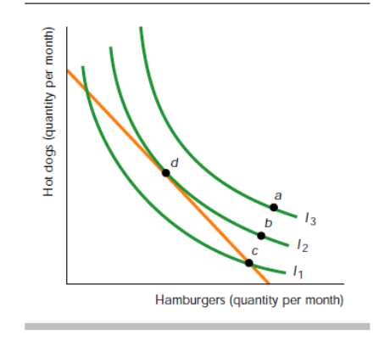
Which of the following is true?
- The consumer is indifferent between point c and point d
- The consumer cannot afford point a
- Point b is preferred to point d
- The consumer cannot afford point c

- The marginal rate of substitution is
- The slope of any point on the indifference curve
- The slope of the market demand curve
- The slope of the isoquant curve
- The slope of the budget constraint line
- The figure below shows Peter’s budget constraint line. The two goods are CDs and magazines.

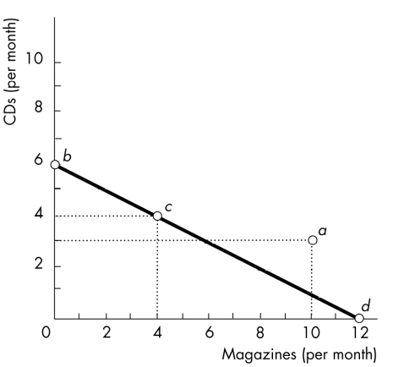
Which combinations of CDs and magazines are NOT affordable to Peter?
- Combination a
- Combination b
- Combination c
- Both combination c and d

- Terry has an income of NAf.100. The figure below shows his budget constraint line.
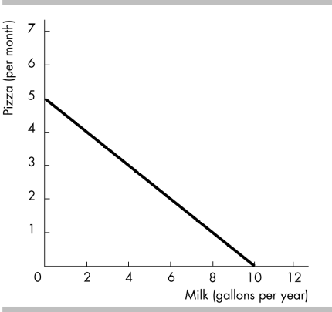
0 -5 / 10 – 0 = -5 / 10 = -0.5
What is the slope of Terry’s budget constraint line?
- -0.5
- 0.5
- 2
- -2
- Consider the figure below:
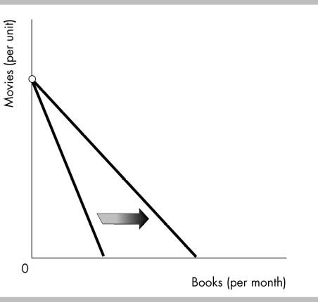

The budget constraint line will rotate in the direction indicated if
- The price of books decreases
- The price of books increases
- The price of movies decreases
- The price of movies increases

- Jenny’s Cupcake factory has the following cost schedule

Output (number of cupcakes) | Variable cost | Total Cost
0 | 0 | 5
1 | 15 | 20
2 | 25 | 30
3 | 30 | 35

Which of the following is NOT true?
- The constant costs are 5
- The firm experiences diseconomies of scale (we have an economy scale 20/1 = 20, 30/ 2 = 15) 20/15 = 1.7
- The average total cost of 2 cupcakes is 15
- The marginal cost of moving from 2 to 3 cupcakes is 5

- Suppose a firm increases all its input factors (labor and capital) by 100% and its total output increases by only 50%. In this case the production function of this firm exhibits
- constant returns to scale (100%)
- decreasing returns to scale (less then 100%)
- increasing returns to scale (only if higher then 100%)
- zero returns to scale

- A firm’s production function is Q=6*KL, where K is capital and L is labor. This production function exhibits
- economies of scale
- constant returns to scale
- diseconomies of scale
- increasing returns to scale


- In 2021, the nominal GDP of country X was $3210 million while its GDP deflator was 107. Calculate the real GDP of country X.
Answer (show your calculations)
Nom gdp / realgdp x 100
107 / 100 = 1.07
3210 / 1.07 = 3000

- Consider the following data:
GNP | 5200
Net foreign demand | -1200
NIA (net income abroad) | -500
Depreciation | 1000

Calculate:
- GDP 5200 - (– 500) = 5700

- Domestic demand
GDP – Net for dem = dom dem
5700 – (-1200) = 6900
- NNP (net national product)
GNP – depreciation
5200 – 1000 = 4200

- In 2017, Hurricane Irma destroyed much of the tourism infrastructure in Sint Maarten. In fact, several hotels and other businesses in the tourism sector had to close for a few months after the hurricane because of the damage that was caused. Use the model of aggregate demand and short run aggregate supply to determine how this event affected real GDP and inflation in Sint Maarten.
- Determine which curve will shift
Supply
- Determine whether this will be a shift to the left or to the right
- Use the model of aggregate demand and short run aggregate supply to determine what happened to GDP and inflation.
- In case there was inflation, what type of inflation did this event cause?

